**PASOS EN GIT BASH**

Botón derecho del mouse y aparece las opciones de Git Bash.(Open Git Bash here)

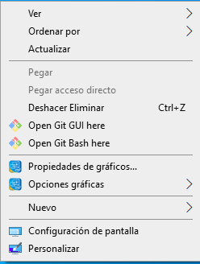

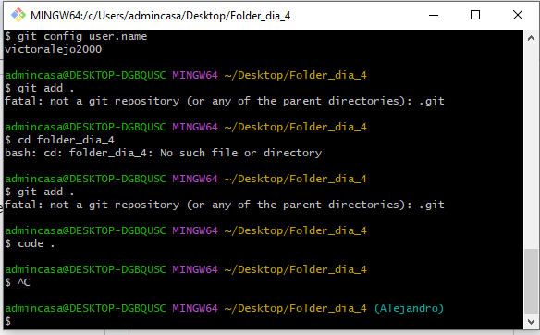

**COMANDOS INICIALES**

**$ mkdir Folder_dia_4** (Crear carpeta)

**$ cd Folder_dia_4/** (Ingresar a la carpeta)

**$ touch index.html** (Crear archivo html)

**$ touch style.css** (Crear archivo CSS)

**$ code .** (Ejecuta Visual Studio Code en la carpeta creada)

**PASOS EN VISUAL STUDIO CODE**

**Editar y modificar el archivo Html y CSS.**

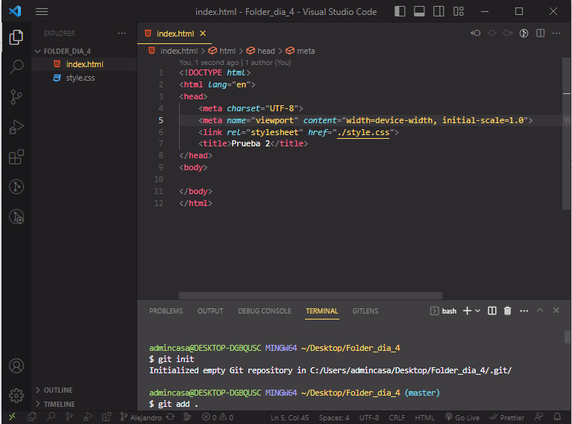

**COMANDOS TERMINAL EN VISUAL STUDIO CODE**

**$ git init**

Initialized empty Git repository in C:/Users/admincasa/Desktop/Folder_dia_4/.git/

**$ git add** .

**$ git commit -m "new file"**

[master (root-commit) d2127ae] new file

2 files changed, 11 insertions(+)

create mode 100644 index.html

create mode 100644 style.css

**$ git remote add origin https://github.com/victoralejo2000/Prueba20JUL23**

**$ git remote -v**

origin https://github.com/victoralejo2000/Prueba20JUL23 (fetch)

origin https://github.com/victoralejo2000/Prueba20JUL23 (push)

**$ git push origin master**

Enumerating objects: 4, done.

Counting objects: 100% (4/4), done.

Delta compression using up to 4 threads

Compressing objects: 100% (3/3), done.

Writing objects: 100% (4/4), 408 bytes | 408.00 KiB/s, done.

Total 4 (delta 0), reused 0 (delta 0), pack-reused 0

To https://github.com/victoralejo2000/Prueba20JUL23

* [new branch] master -> master

**$ git checkout -b Alejandro**

Switched to a new branch 'Alejandro'

**$ git add .**

**$ git commit -m "rama nueva"**

On branch Alejandro

nothing to commit, working tree clean

**$ git push -u origin Alejandro**

Total 0 (delta 0), reused 0 (delta 0), pack-reused 0

remote:

remote: Create a pull request for 'Alejandro' on GitHub by visiting:

remote: https://github.com/victoralejo2000/Prueba20JUL23/pull/new/Alejandro

remote:

To https://github.com/victoralejo2000/Prueba20JUL23

* [new branch] Alejandro -> Alejandro

branch 'Alejandro' set up to track 'origin/Alejandro'.

**$ git add .**

**$ git commit -m "link style"**

[Alejandro dc04be9] link style

1 file changed, 1 insertion(+)

**$ git push -u origin Alejandro**

Enumerating objects: 5, done.

Counting objects: 100% (5/5), done.

Delta compression using up to 4 threads

Compressing objects: 100% (3/3), done.

Writing objects: 100% (3/3), 348 bytes | 348.00 KiB/s, done.

Total 3 (delta 1), reused 0 (delta 0), pack-reused 0

remote: Resolving deltas: 100% (1/1), completed with 1 local object.

To https://github.com/victoralejo2000/Prueba20JUL23

d2127ae..dc04be9 Alejandro -> Alejandro

branch 'Alejandro' set up to track 'origin/Alejandro'.